**Tugas Struktur Data**

**Membuat contoh dari masing masing big o notation**

**Dosen pengampu Muhammad Reksa Ariansyah, M.Kom.**

**Dhafa Azmi Athallah**

**22552011110**

1. **Constant Time Algorithms – O(1)**

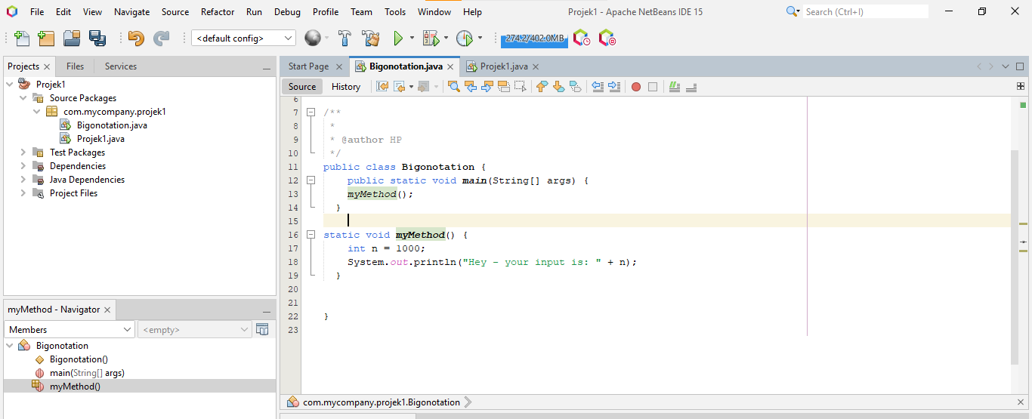

1. **Linear Time Algorithms – O(n)**

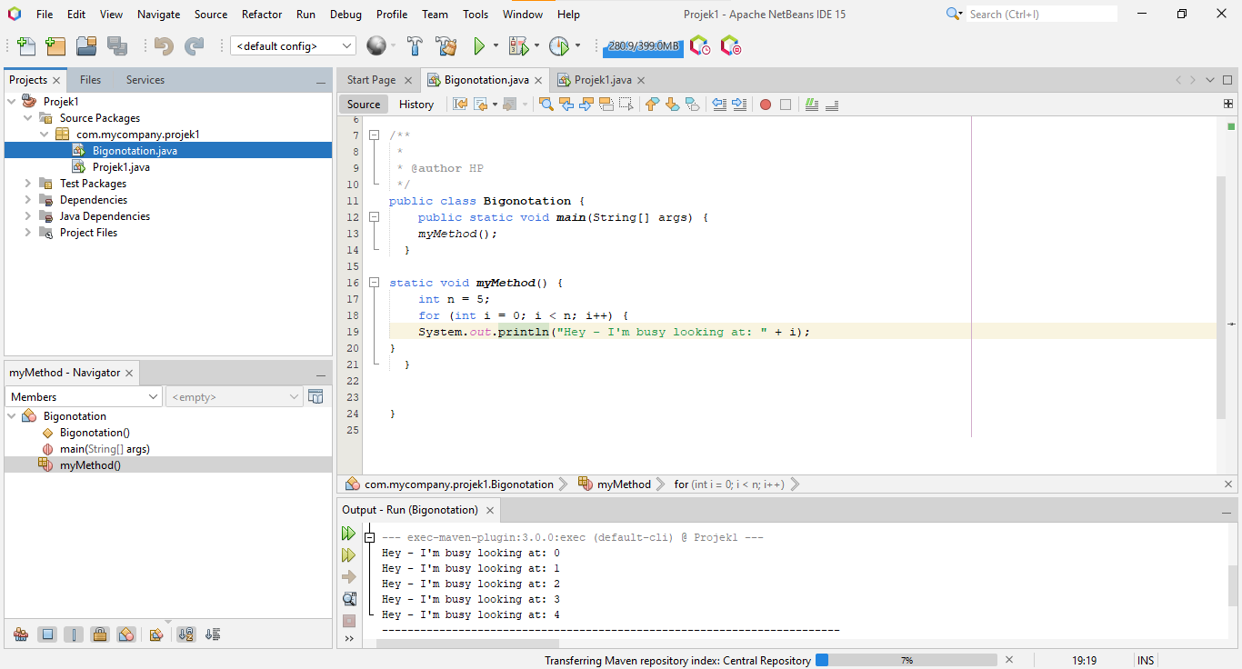

1. **N Log N Time Algorithms – O(n log n)**

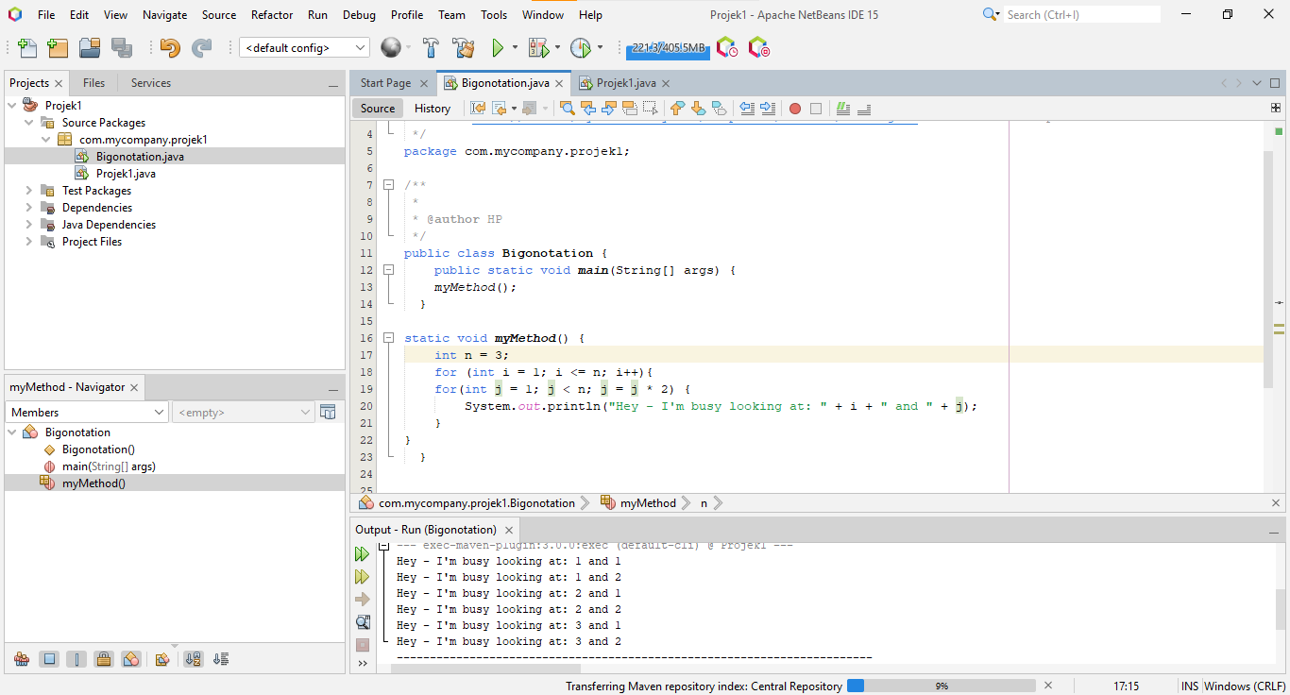

1. **Exponential Time Algorithms – O(kn)**

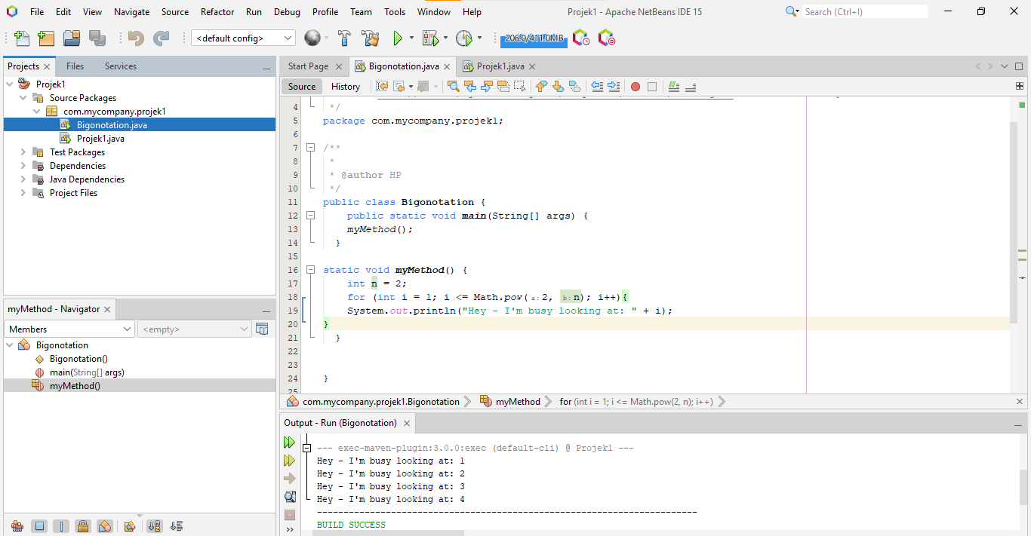

1. **Factorial Time Algorithms – O(n!)**

